A Project Report on

“Jagdamba sales & corporation E-commerce Project”
Submitted in Partial Fulfilment for Award of Degree of Master of Computer Application Semester 4

MR. PRATIKKUMAR PARMAR | 235300694035

Internal Guide

Dr. Jonita Roman



SARDAR VALLABHBHAI PATEL INSTITUTE OF TECHNOLOGY, VASAD
Affiliated to
GAJARAT TECHNOLOGY UNIVERCITY
April 2025

Date:

Certificate

This is to certify that the project entitled “Dairy Supply Chain Management System” is a bonafide record of the work carried out by

- Jaini Dhobi (225300694012)
- Priti Padhiyar (225300694032)
- Vaishakhi Padhiyar (225300694033)

-under my guidance and supervision for the partial fulfilment of the award of degree of Master of Computer Applications of Sardar Vallabhbhai Patel Institute of Technology, Department of MCA, Vasad, Gujarat.
To the best of my knowledge and belief, this project work embodies the work of the candidate.

Dr. Jonita Roman Prof. Zankhana Bhatt
HOD Assistant Professor,
MCA Dept., Internal Guide,
S.V.I.T., Vasad, Gujarat S.V.I.T., Vasad, Gujarat

ACKNOWLEDGEMENT

The accomplishment of this project would have not been possible individually without the encouragement, assistance and valuable support from various sources. It is our proud privilege to express our profound gratitude to the entire management of Sardar Vallabhbhai Patel Institute of Technology and teachers of the institute for providing us with this opportunity to avail the excellent infrastructure. The knowledge and values gained have provided to be of immense help at the very start of our career. Special thanks to Honourable Head of the Department, Dr. Jonita Roman for having provided us an excellent infrastructure at SVIT.
No creative work is possible in isolation. We need guidance, motivation at every step of our progress. We would like to add a few heartfelt words for the people who were the part of this project in numerous ways. We are grateful to Dr. Jonita Roman (project guide) for her guidance, constant encouragement and sincere support for this project work.
We extend our heartfelt thanks to for giving us an opportunity to work in such good professional environment and have a good experience.
- Pratikkumar Parmar

INDEX

INDEX |  | SUBJECT(CONTENTS) | PAGE NO
1. |  | Introduction | 1-3
 | 1.1 | Existing System | 1
 | 1.2 | Need for the New System | 1
 | 1.3 | Objective of the New System | 1
 | 1.4 | Problem Definition | 2
 | 1.5 | Core Components | 2
 | 1.6 | Project Profile | 2
 | 1.7 | Assumptions and Constraints | 3
 | 1.8 | Advantages and Limitations of the Proposed System | 3
2. |  | Requirement Determination & Analysis | 4
 | 2.1 | Requirement Determination | 4
 | 2.2 | Targeted Users | 4
3. |  | System Design | 5
 | 3.1 | Use Case Diagram | 5
 | 3.2 | Class Diagram | 7
 | 3.3 | Interaction Diagram | 8
 | 3.4 | Activity Diagram
 | 3.5 | Data Dictionary
4 |  | Development
 | 4.1 | Screen Shots
5 |  | Agile Documentation
 | 5.1 | Agile Project Charter
 | 5.2 | Agile Roadmap / Schedule
 | 5.3 | Agile Project Plan
 | 5.4 | Agile User Story
 | 5.5 | Agile Release Plan
 | 5.6 | Agile Sprint Backlog
 | 5.7 | Agile Test Plan
 | 5.8 | Earned Value (EV) Calculation & Burn Chart
6 |  | Proposed Enhancements
7 |  | Conclusion
8 |  | Bibliography

- INTRODUCTION:

The Jagdamba Sales and Corporation E-Commerce Project is a comprehensive digital platform consisting of an Admin Panel and an E-Commerce Website to streamline online sales, order processing, and inventory management.

The Admin Panel enables efficient product management, order tracking, inventory monitoring, and customer management, ensuring smooth backend operations.

The E-Commerce Website provides a user-friendly shopping experience with secure user authentication, product browsing, shopping cart functionality, multiple payment options, and order tracking. Built using React.js for the front end, Node.js/Express for the backend, and MongoDB for database management, this project ensures scalability, security, and high performance while optimizing business operations and enhancing customer satisfaction.

Existing System:
    - Managing the Supply Chain in Todays E-Commerce Industry Without Modern Technology.
    - Consume More time
    - Maintaining Quality and Quantity within a Different Supply Chain Poses a Major Challenge.
    - Irregular Delivery.
    - Changing Consumer Requirement.
    - Difficult to Handle Data.

Need for the New System:

    - Product management,
    - Employee management,
    - Customer management,
    - Inventory management,
    - Mobile Accessibility.
    - Order Tracking management,
    - Customers Communication &Feedback.
    - Sustainability(eco-friendly)
    - Save Lots of Time

Objective of the New System:
The objective of Jagdamba Sales & Corporation E-commerce Project is to optimize the production, processing, and distribution of products to ensure efficiency, quality control, cost-effectiveness, and sustainability. This involves managing inventory, ensuring traceability, forecasting demand, promoting collaboration among stakeholders, and complying with regulatory standards to meet customer satisfaction and market demands.

Problem Definition:
Jagdamba Sales & Corporation E-commerce Project faces challenges including seasonal variability in production, Unstable of products, quality control issues, the complexity of maintaining a cold chain, Agreement to evolving regulations, market volatility, traceability concerns, sustainability expectations, and the integration of advanced technologies. Effectively addressing these challenges is crucial for ensuring the efficiency, quality, and sustainability of the supply chain.
And about identifying the challenges and issues faced in getting Products from the Suppliers to consumers. This includes problems like coordinating transportation, storage, and distribution efficiently while maintaining quality and reducing costs.

Core Components:

Registration:
    - Company can register as a vender site admin
    - User can register as a customer
    - Delivery person register as a delivery boy

Login:

    - Company
    - Customer
    - Delivery

Project Profile:

Project Title: | “Jagdamba Sales & Corporation E-commerce Project”
Institute: | Sardar Vallabhbhai Patel institute of technology, Vasad
Duration: | 4 months
Team: | - Pratikkumar Parmar: 235300694035
Guide: | Dr. Jonita Roman
Front End: | React JS
Back End: | Node JS, Express
Database: | Mongo DB

  - Assumptions and Constraints:
We have assumed after the making of the web application by validation control and made error-free application for the company requirement if the error will come and directors want to modify the web application, so the company depends on us because we Have taken the responsibility for the entire application.

Advantage and Limitations:

Advantages:

    - Save Money.
    - Customer Satisfaction.
    - Risk Mitigation.
    - Save time
    - Easily Handle data
    - On time delivery
    - Payment’s option available

Limitations:

    - The application needs availability of internet continuously.
    - It can be difficult to measure their effectiveness.
    - There is lots of competition.

Requirement Determination and Analysis:

Requirement Determination

    - Software Requirements:

      - Windows 8 or above
      - Browser
    - Hardware Requirements:

      - RAM: 2GB
      - ROM: 256GB
      - Internet Connectivity

Targeted Users

- Super Admin
- Admin
- CRM
- Customer
- Order Tracking Person

System Design:

Use Case Diagram
    - Admin Panel (Marketing site):

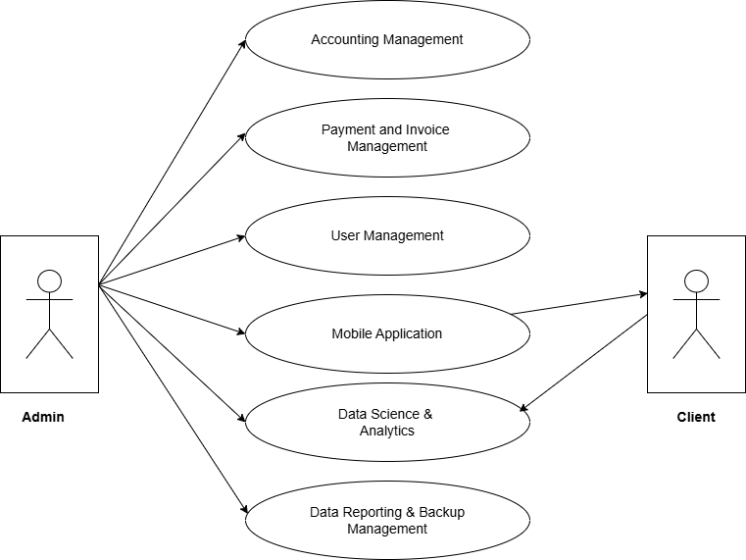
    - Client-Side Admin Panel:

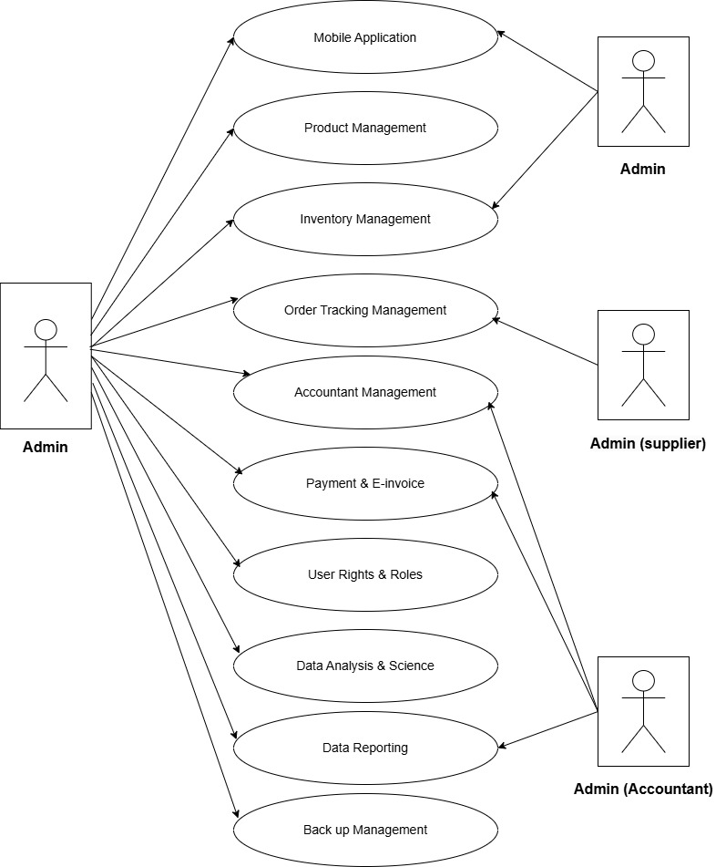

  - Class Diagram: (Super-Admin, Vendor-Admin, Customer, Delivery-person)

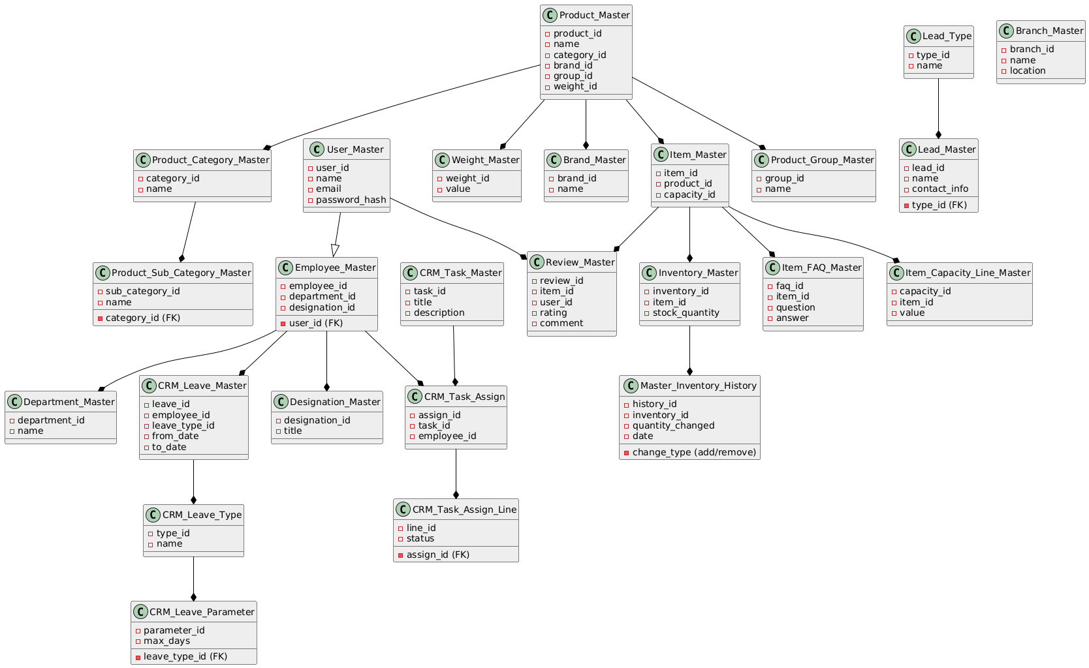
  - Interaction Diagram: (Super-Admin, Vendor-Admin, Customer, Delivery-person)

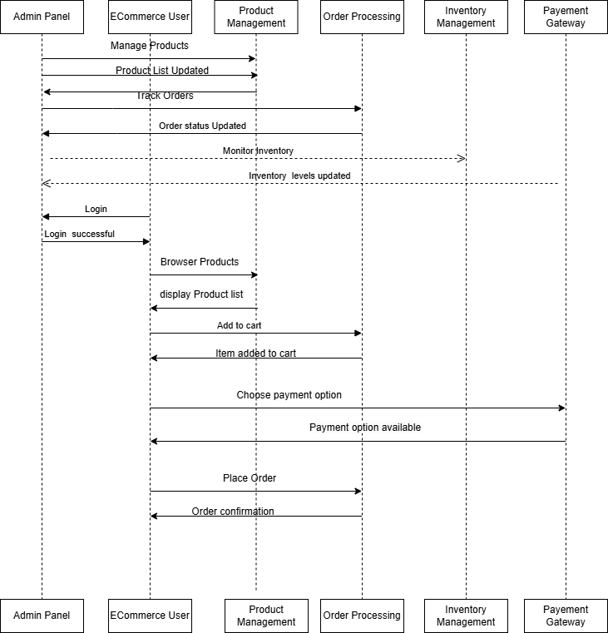
Activity Diagram:
    - Marketing side Admin Panel:
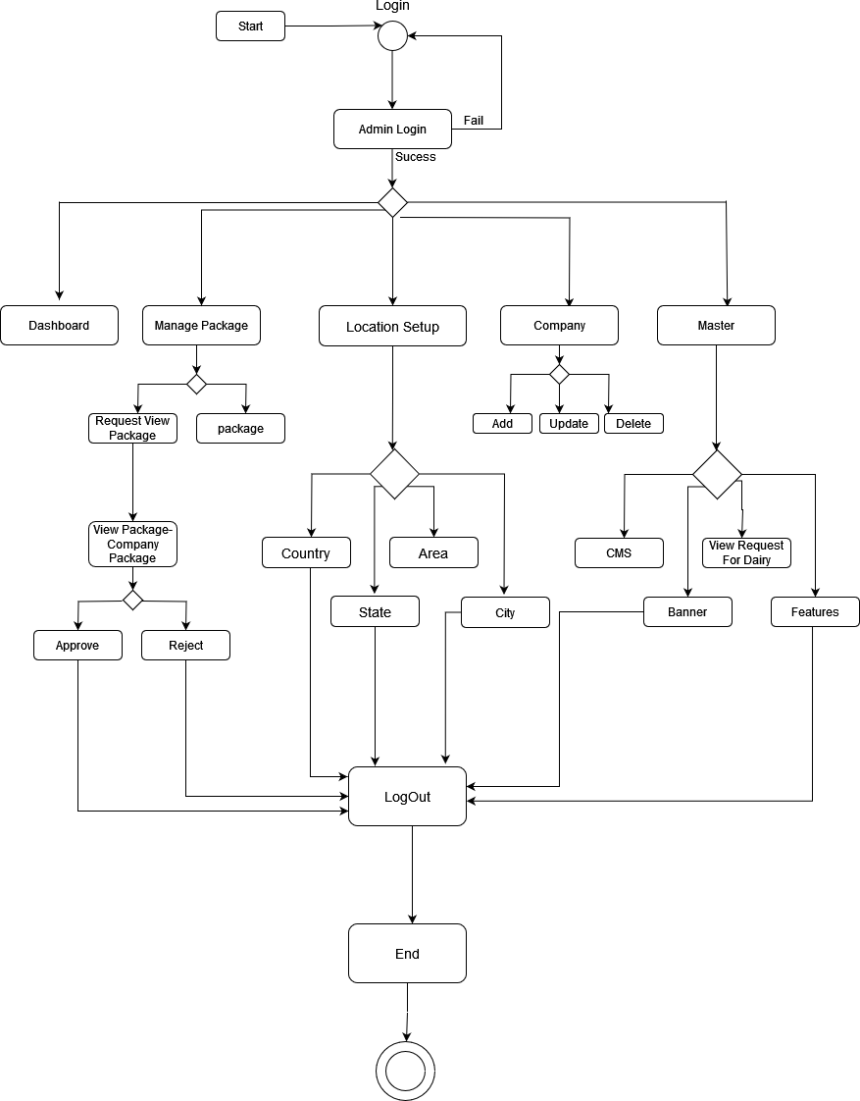
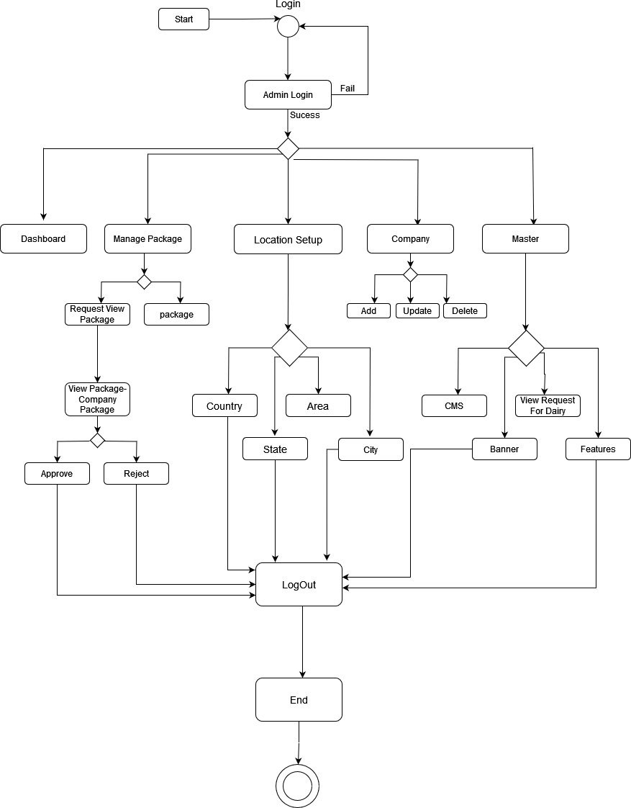
Products
Products
Delete products

Delivery Side Application:

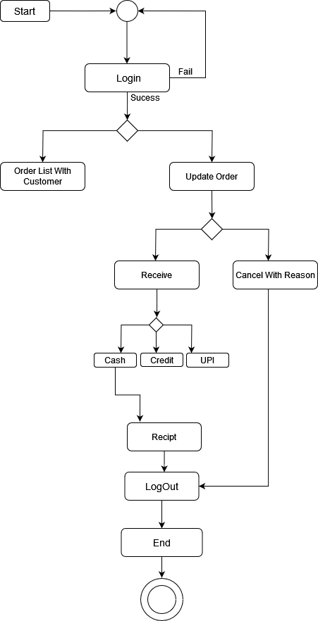

Data Dictionary:

Table Name: - Customer_Master
Description: - For Customer Parameter in All-over Admin panel and super Admin panel.

Name | Type | Length | Description
_id | int |  | Unique entry id for each record
Customer name | varchar | (10) | Add Country name
Mobile No | int | (5) | Add Country code
Address | varchar |  | Data is stored in database.
Username | varchar |  | Add Address
Password | varchar |  | Add Username
isAdded | DATETIME |  | Add Password
isAddedBy | int |  | Timestamp when the record was added.
isUpdate | DATETIME |  | User ID of the person who added the record.
isUpdateBy | int |  | Timestamp of the last update to the record.
isDelete | DATETIME |  | Timestamp when the record was marked as deleted.
isDeleteBy | int |  | User ID of the person who deleted the record.

Table Name: - Unit master
Description: - For Count Quantity of Product in All-over Admin panel and for customer.

Name | Type | Length | Description
_id | Int |  | Unique entry id for each record
Kg | int | Not null | Add kg (for inventory mng)
Gram | Int | Not null | Add gram (for inventory mng)
Ml | Int | Not null | Add ml (for inventory mng)
Liter | Int | Not null | Add liter (for inventory mng)
isActive | Boolean | Boolean | Data is stored in database.

Table Name: - Product Category
Description: - Add Product Category For Add Product as category vise..

Name | Type | Length | Description
_id | Int |  | Unique entry id for each record
Product_Category | Varchar | (10) | Add product category
isActive | Boolean | Boolean | Data is stored in database.

Table Name: - Department Master
Description: - For Department Parameter in All-over Admin panel and super Admin panel.

Name | Type | Length | Description
Id | INT | - | Unique entry id for each record for the department.
Department_Name | VARCHAR | 100 | Full name of the department.
Department_Code | VARCHAR | 20 | Short code for the department.
Department_Short_Name | VARCHAR | 50 | Abbreviated name
IsAdded | DATETIME | - | Timestamp when the record was added.
IsAddedBy | INT | - | User ID of the person who added the record.
IsUpdate | DATETIME | - | Timestamp of the last update to the record.
IsUpdateBy | INT | - | User ID of the person who last updated the record.
IsDelete | DATETIME | - | Timestamp when the record was marked as deleted.
IsDeleteBy | INT | - | User ID of the person who deleted the record.

Table Name: - Designation_Master

Description: - For Location Parameter in All-over Admin panel and super Admin panel.

Name | Type | Length | Description
_id | int |  | Unique id for each record
Designation_Name | varchar | (10) | Add Designation name
Designation_Code | varchar | (10) | Add Designation Code
Designation_ShortName | varchar | (10) | Add Designation Short name
IsAdded | DATETIME | - | Timestamp when the record was added.
is Active | int | - | Data is stored in database.
IsAddedBy | DATETIME | - | Timestamp when the record was added.
IsUpdate | int | - | Timestamp of the last update to the record.
IsUpdateBy | DATETIME | - | User ID of the person who last updated the record.
IsDelete | int | - | Timestamp when the record was marked as deleted.
IsDeleteBy | DATETIME | - | User ID of the person who deleted the record.

Table Name: - Product_Master

Description: - For Product Parameter in All-over Admin panel and super Admin panel.
Name | Type | Length | Description
Id | INT | - | Unique id for products.
Product_Name | VARCHAR | 255 | Full name of the product.
Product_Image | VARCHAR | 500 | File path/URL of the product image.
Product_TagLine | VARCHAR | 255 | Short marketing slogan.
IsGroup | BOOLEAN | - | Indicates if the product belongs to a group (true/false).
IsAdded | DATETIME | - | Timestamp when the product was added.
IsAddedBy | INT | - | User ID of the person who added the product.
IsUpdate | DATETIME | - | Timestamp of the last update to the product.
IsUpdateBy | INT | - | User ID of the person who last updated the product.
IsDelete | DATETIME | - | Timestamp when the product was marked as deleted.
IsDeleteBy | INT | - | User ID of the person who deleted the product.

Table Name: - Product-Category Master

Description: - For Product-category Parameter in All-over Admin panel and super Admin panel.

Name | Type | Length | Description
id | int |  | Unique entry id for each record
Product_Name | varchar | (10) | Add Product name
Product_Image | varchar | (10) | Add Product Image
Product_TagLine | varchar | (10) | Add Product TagLine
IsGroup | Boolean | bool | Add area name
IsAdded | DATETIME |  | Timestamp when the product was added.
IsAddedBy | int | - | User ID of the person who added the product.
IsUpdate | DATETIME | - | Timestamp of the last update to the product.
IsUpdateBy | int | - | User ID of the person who last updated the product.
IsDelete | DATETIME | - | Timestamp when the product was marked as deleted.
IsDeleteBy | int | - | User ID of the person who deleted the product.

Table Name: - Employee Master
Description: - For Add Employee As different designation and department for Admin-panel.

Name | Type | Length | Description
_id | Int |  | Unique entry id for each record
Emp_branch | varchar | (10) | Add branch of employee
Emp_Name | Varchar | (15) | Add name of employee
Emp_Email | Varchar | (20) | Add Email of employee
Emp_Doj | Date | Not null | Add Date of joining of employee
Emp_Alt_Num | Int | (10) | Add Alter native number of employees
Emp_Add | Varchar | (50) | Add address of employee
Emp_Dept | Varchar | Not null | Add department of employee
Emp_Desg | Varchar | Not null | Add designation of employee
Emp_Uname | Varchar | (8) | Add user name of employee
Emp_Pwd | Varchar | (8) | Add password of employee
Emp_Admin | Check | Check | Check whether it is admin of employee
is Active | Boolean | Boolean | Data is stored in database.

Table Name: - Order_Payment_History
Description: - For Payment of Delivered Products from Customer to Vendor side Admin.

Name | Type | Length | Description
_id | Int |  | Unique entry id for each record
Order/Id | Int | Not null | View order id
Product_Name | Varchar | (8) | View product name
Produst_Quantity | Int | (5) | View product quantity
Product_Total | Int | (5) | View total product
Product_Base_Price | Int | (5) | View product-based price
isActive | Boolean | Boolean | Data is stored in database.

Table Name: - Order Master
Description: - For Manage orders, Payment of orders for customers and Admin.

Name | Type | Length | Description
_id |  |  | Unique entry id for each record
Company_Id | int | Not null | Add company id
Cust/Id | int | Not null | Add customer unique id
Order Total | Int | (5) | View total order
Deliver_Order_Date | Date | Not null | Date of delivery of order list
Place_Order_Date | Date | Not null | Place order date
Is Payment | Boolean | Boolean | Check whether payment is succussed

IsActiveOrder | Boolean | Boolean | Data is stored in database.
Pay_Order_Amount | Int | (5) | Pay order amount
Panding_Order_Amount | Int | (5) | Pending order amount
isActive | Boolean | Boolean | Data is stored in database.

Table Name: CMS
Description: - For Adding Pages and Content to marketing site.

Name | Type | Length | Description
_id | Int |  | Unique entry id for each record
Page Title | int | Not null | Change page title
Content_Desc | varchar | (50) | Add content description
isActive | Boolean | Boolean | Data is stored in database.

Table Name: - Banner Master
Description: - For Add update & delete Banners in All over Marketing Site.

Name | Type | Length | Description
_id |  |  | Unique entry id for each record
Page Title | int | Not null | Add page title
Banner_Img | Row | Row | Add banner image
Banner_Desc | varchar | (50) | Add banner description
Content_Desc | Varchar | (50) | Add content description
isActive | Boolean | Boolean | Data is stored in database.

Table Name: - Inventory
Description: - For Manage Stock of Products and upcoming Products

Name | Type | Length | Description
_id |  |  | Unique entry id for each record
Product/Id | int | Not null | View product id
ProductName | varchar | (20) | View product name
Product Quantity | Int | (5) | View product quantity
is Active | Boolean | Boolean | Data is stored in database.

Table Name: Services
Description: - For Adding new Services in marketing site.

Name | Type | Length | Description
_id | Id |  | Unique entry id for each record
Page Title | int | Not null | Add page title
Add_Services | varchar | (10) | Add services
Services_desc | Varchar | (50) | Add services description
Services_Img | Row | Row | Add services image
is Active | Boolean | Boolean | Data is stored in database.

Table Name: Inquiry Master
Description: - For Inquiry of Whole Marketing site .

Name | Type | Length | Description
_id | Id |  | Unique entry id for each record
Uname | Varchar | (15) | Add user name
UEmail | Varchar | (30) | Add user email
Unum | Int | (10) | Add user number
UInq | Varchar | (20) | Add user inquiry
is Active | Boolean | Boolean | Data is stored in database.

- Development:

4.1: Screenshots:

4.1.1: Marketing Site

- Banner Section

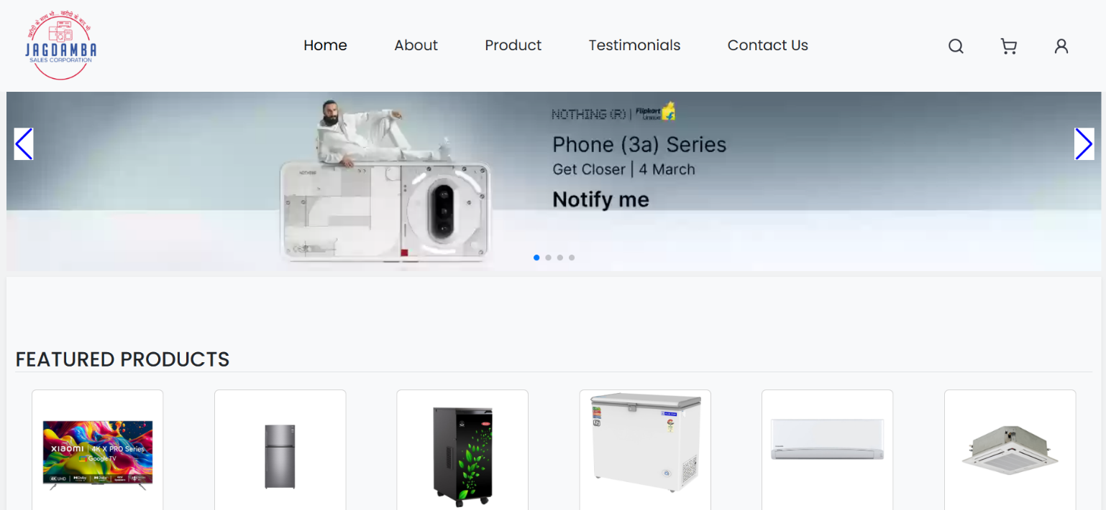

- Features

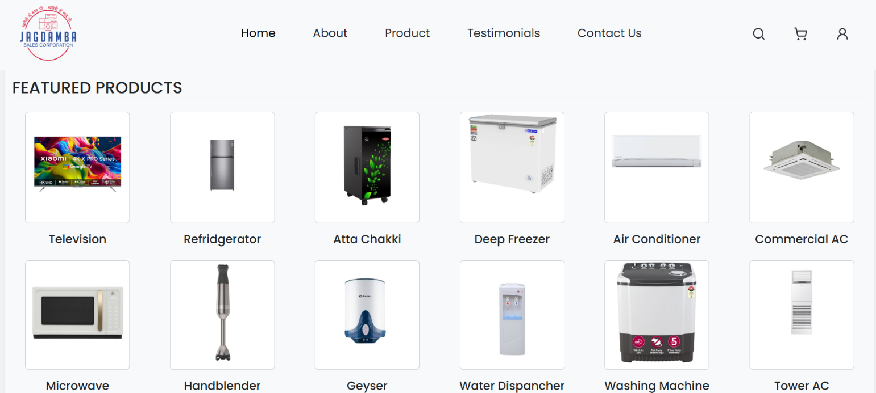

- Product Detail Page

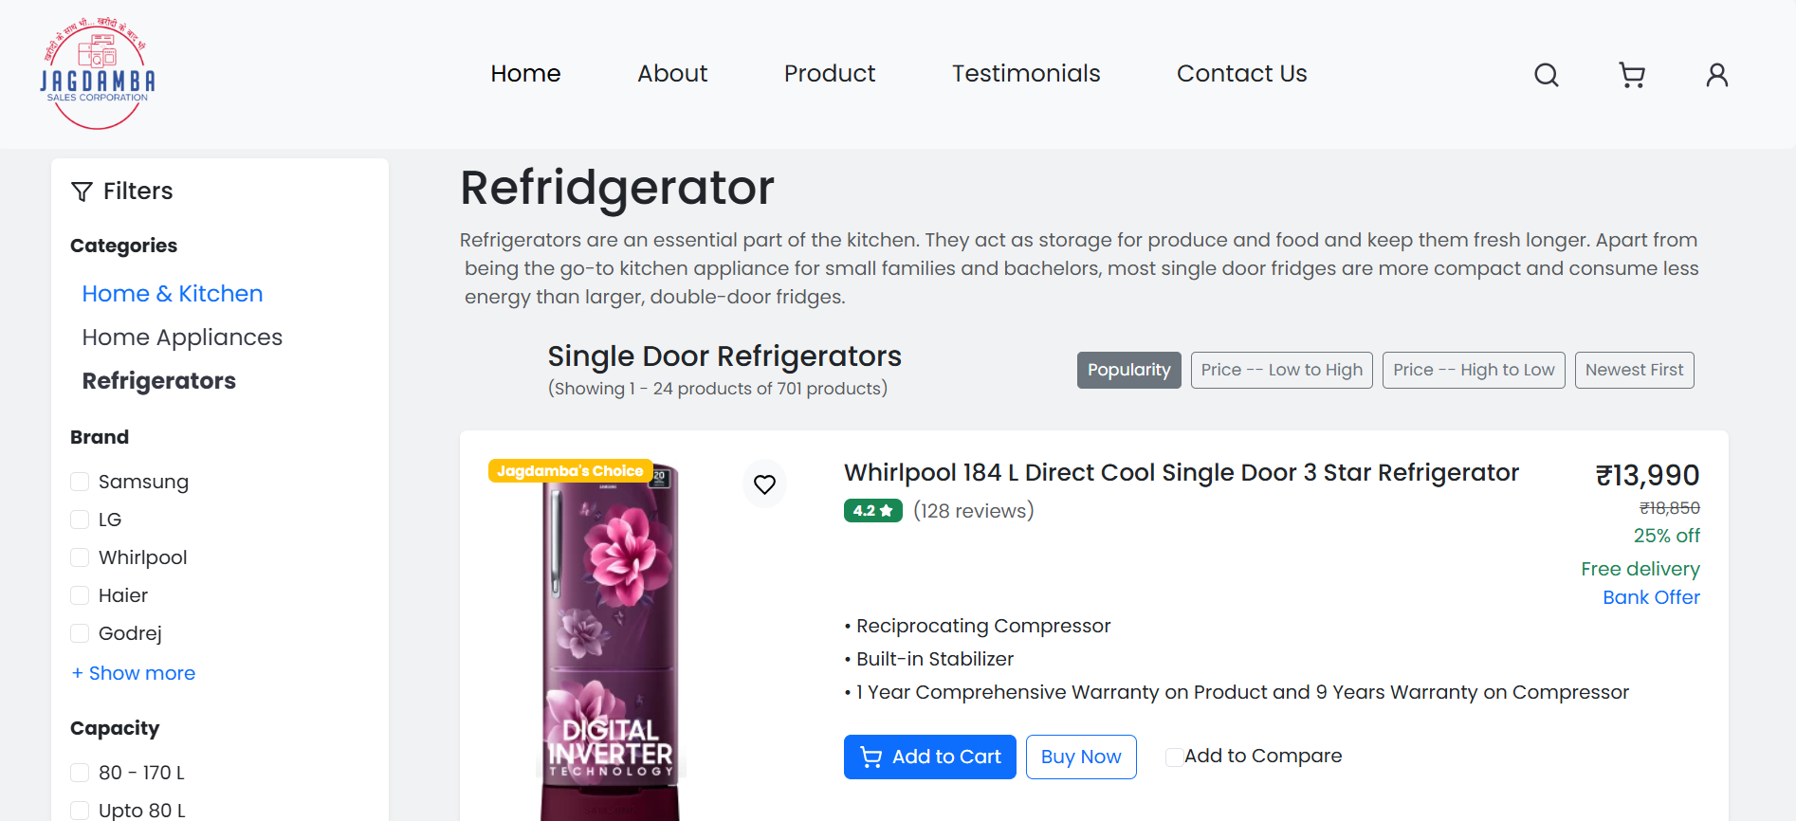

- About Us page
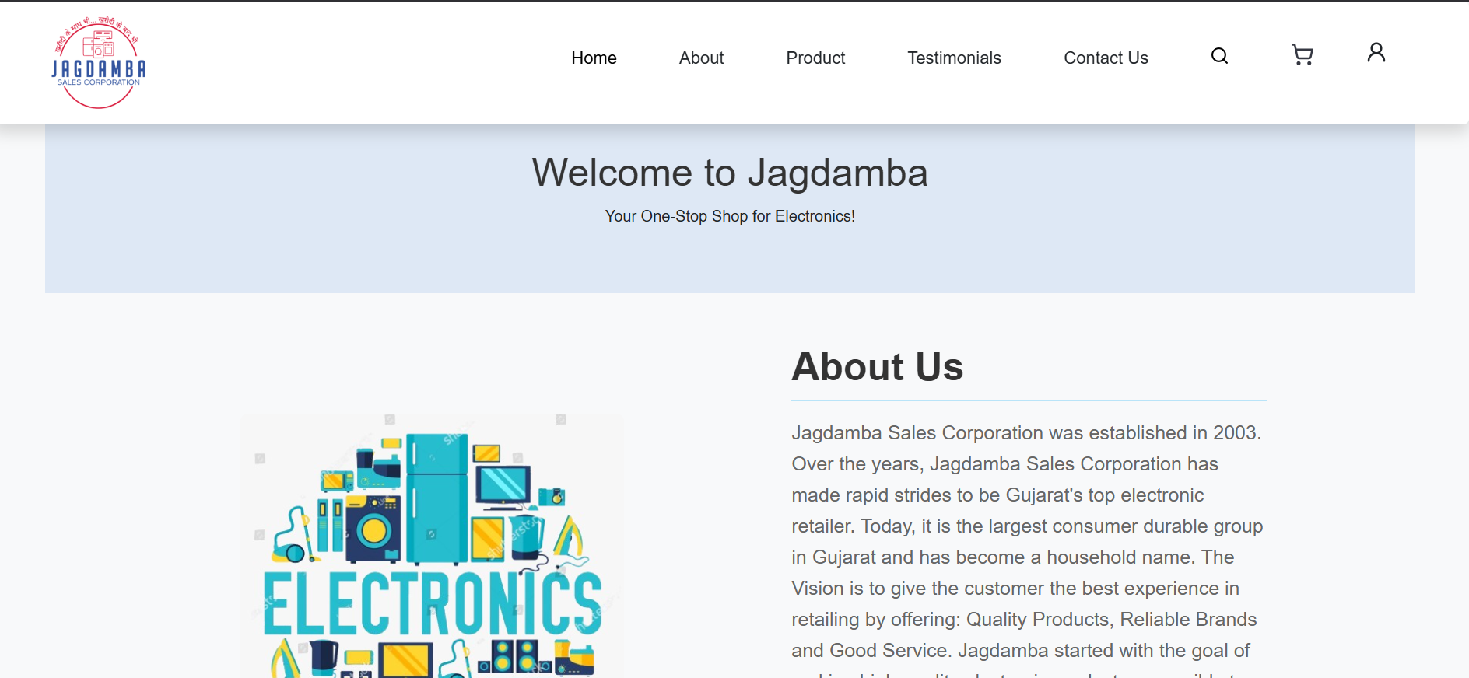

- Contact Us Page

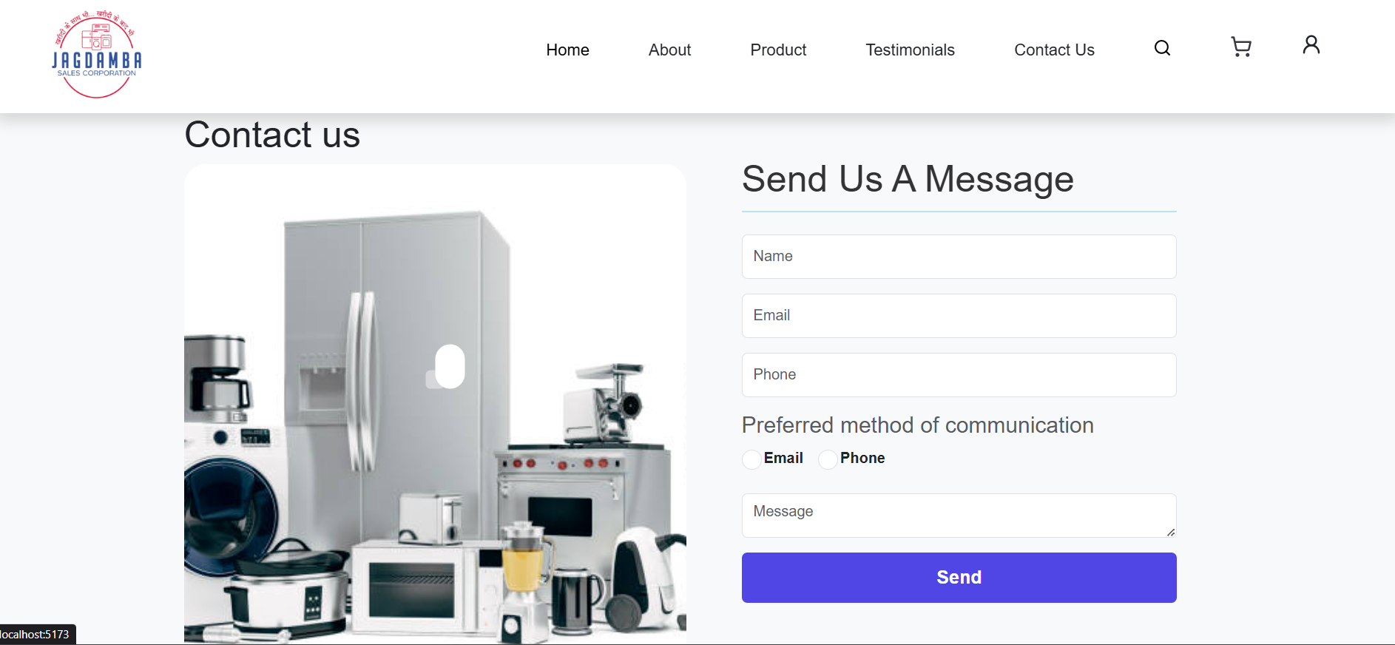

- My Profile Page
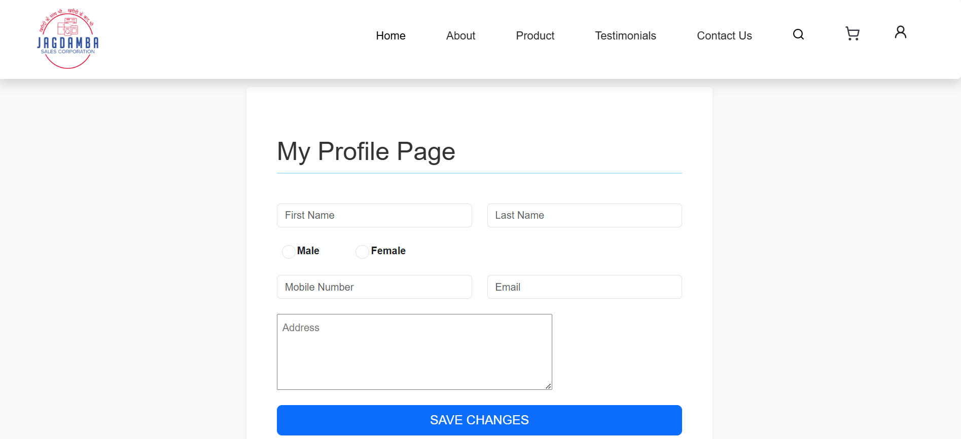

- MyOrder Page
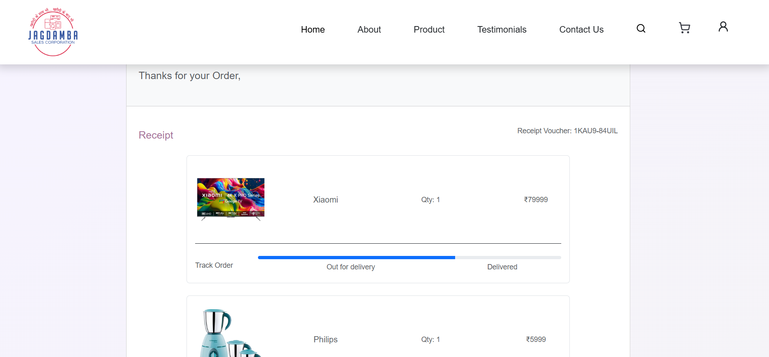

- My WishList Page

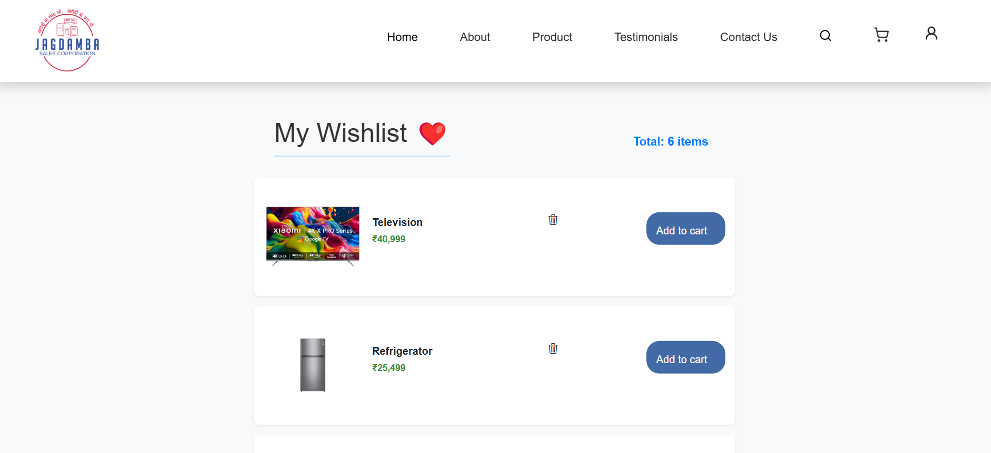

- Product Detail Page
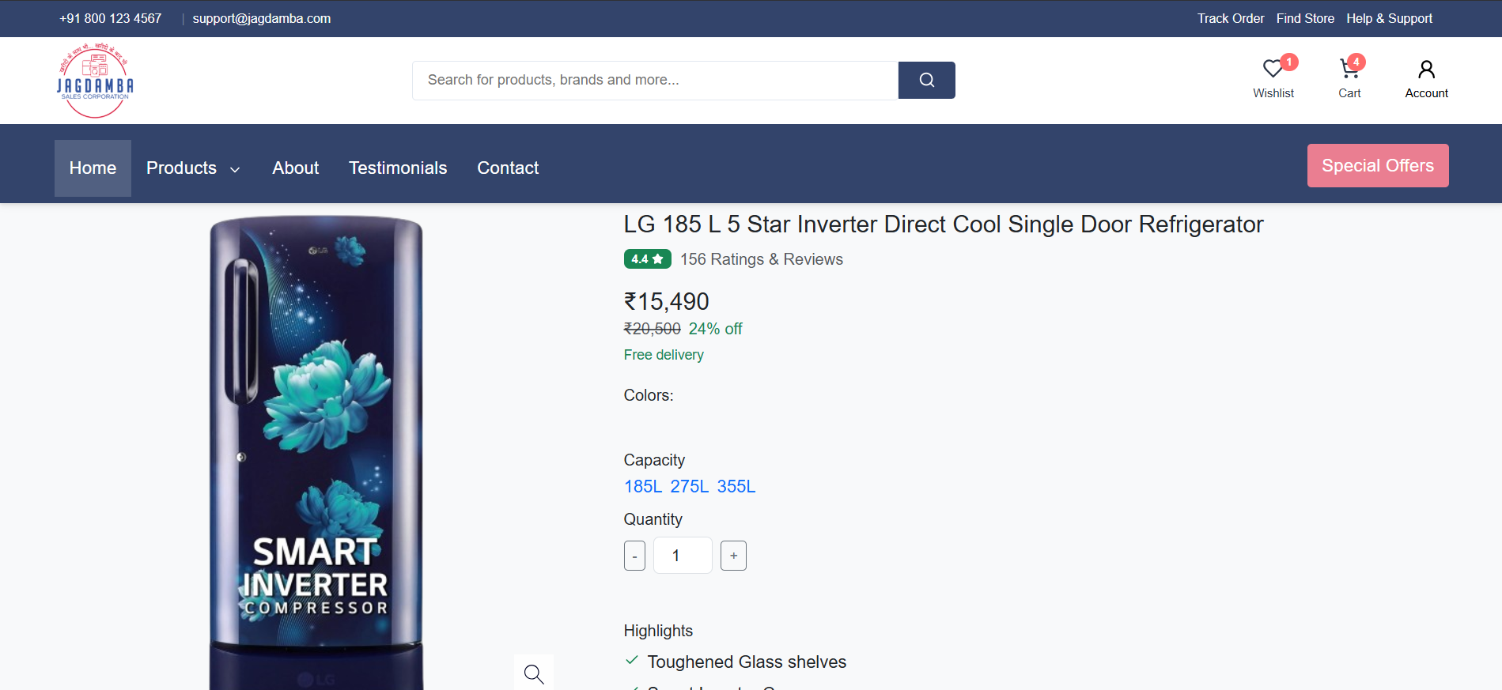

- Login Page
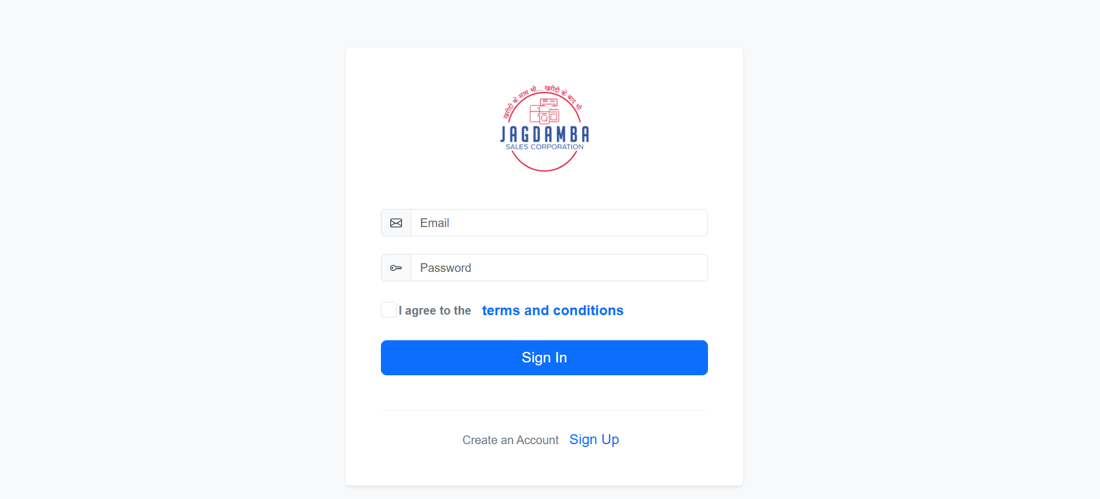

- Sign Up Page
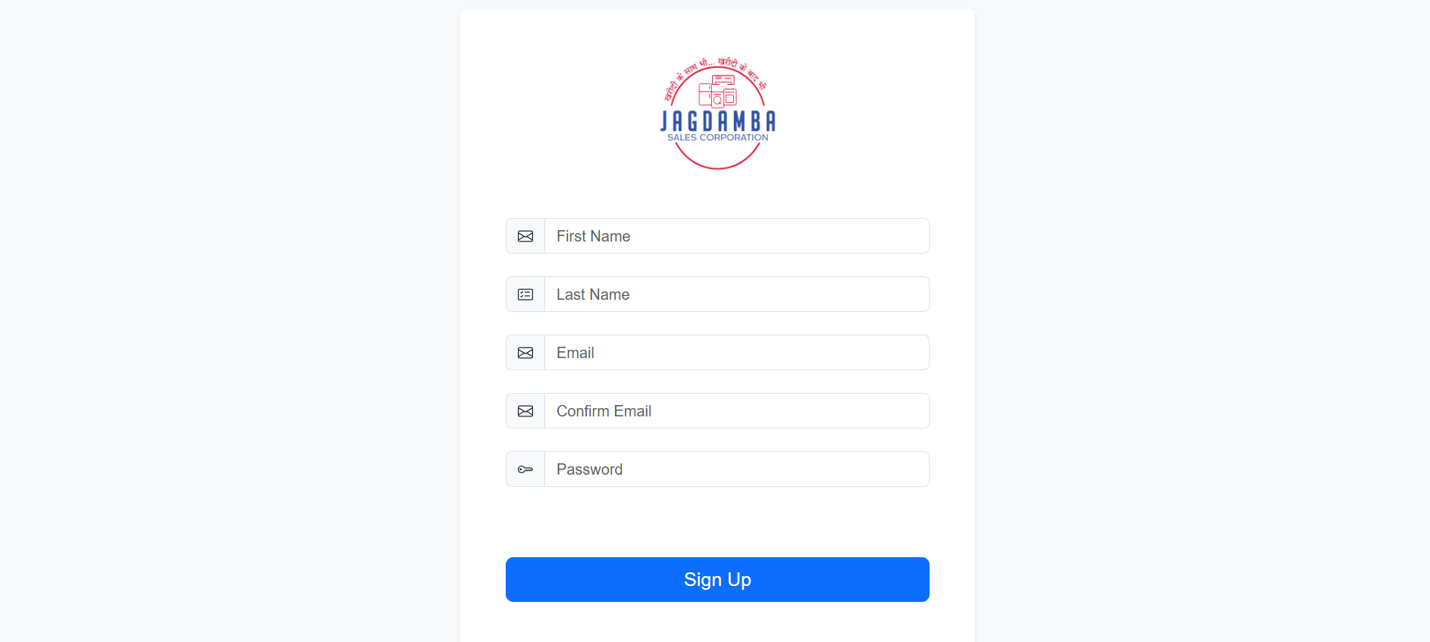

5. Agile Documentation

Agile Project Charter

PROJECT CHARTER
PROJECT TITLE |  |  | STUDENTPG
PROJECT START DATE |  | 10-01-2025 | PROJECT  END DATE |  | 12-04-2025
BUSINESS NEED
The project is developed in sem-3 as partial fulfilment of MCA
PROJECT  SCOPE | The system is designed to provide a complete e-commerce solution for Jagdamaba sales & corporation. It ensures smooth business operations and enhances the customer experience. |  |  | DELIVERABLES | MCA dept
RISK AND ISSUES | 1) Project risks– without internet user can’t open the application, without login, register user can’t place the request.  2)Technical risks– if there is no internet then system is not going to work.  3)Business risks–no business risk. |  |  | Assumption And Dependencies | Page No:- 7
MILESTONE SCHEDULE
MILESTONE |  | DATE | TEAM  MEMBERS |  | Review  Committee
1st review  Final-submission |  | 25-09-2025  19-10-2025 | Pratik Parmar-  235300694035 |  | Project guide:  DR. Jonita Roman

Agile Roadmap / Schedule

1st QUARTER | 2nd QUARTER
Understand project definition, gather requirement and finalise the project scope | We design the system and draw various diagram such as:  - Use case diagram for system and prepare data dictionary.
3rd QUARTER | 4th QUARTER
We implement the crude operation of the project, tested the module and documentation is prepared side by side | We integrate all modules and tested overall system; whatever changes happen are incorporated also documentation is made side by side
FINAL QUARTER
Final presentation and final documentation to be done

Agile Project Plan

TASK NAME | RESPONSIBLE | DAYS | STATUS
SPRINT 1 | SELF | 15 | Complete
Project Definition | SELF | 2 | Complete
Gather Requirement | SELF | 7 | Complete
Project Scope | SELF | 5 | Complete
SPRINT 2 | SELF | 31 | Complete
Use Case Diagram | SELF | 4 | Complete
Class Diagram | SELF | 9 | Complete
State Diagram | SELF | 9 | Complete
Sequence Diagram | SELF | 9 | Complete
SPRINT 3 | SELF | 31 | Complete
Crude Operation | SELF | 10 | Complete
Test the Module | SELF | 11 | Complete
Documentation | SELF | 24 | Complete
SPRINT 4 | SELF | 50 | Complete
Integrate Modules | SELF | 20 | Complete
Test System | SELF | 15 | Complete
Changes  Incorporated | SELF | 8 | Complete
Documentation | SELF | 7 | Complete

Agile User Story
Sr.no | Model Name | Description
User Story 1 | User login | User can login
User Story 2 | User register | User can register
User Story 3 | Add to cart | User can add to cart

Agile Sprint Backlog

TASK NAME | STORY | SPRINT READY | PRIORITY | STATUS | ASSIGNED TO PRINT
SPRINT 1 | YES | YES | LOW | Compete | YES
TASK 1 | YES | YES | MEDIUM | Compete | YES
TASK 2 | YES | YES | MEDIUM | Compete | YES
TASK 3 | YES | YES | LOW | Compete | YES
SPRINT 2 | YES | YES | HIGH | Compete | YES
TASK 4 | YES | YES | HIGH | Compete | YES
TASK 5 | YES | YES | HIGH | Compete | YES
TASK 6 | YES | YES | HIGH | Compete | YES
TASK 7 | YES | YES | HIGH | Compete | YES
SPRINT 3 | YES | YES | HIGH | Compete | YES
TASK 8 | YES | YES | LOW | Compete | YES
TASK 9 | YES | YES | MEDIUM | Compete | YES
TASK 10 | YES | YES | HIGH | Compete | YES
SPRINT 4 | YES | YES | MEDIUM | Compete | YES
TASK 11 | YES | YES | LOW | Compete | YES
TASK 12 | YES | YES | HIGH | Compete | YES
TASK 13 | YES | YES | LOW | Compete | YES
TASK 14 | YES | YES | MEDIUM | Compete | YES

Agile Test Plan
PROJECT NAME | Jagdamba Sales | BROWSER | GOOGLE CHROME
WRITTEN BY | Pratik Parmar 235300694035 | DESCRIPTION | 17-Jan-2025
TESTED BY | Pratik Parmar 235300694035 | TESTED ON | 10-April -2022

TEST | DATE | ACTION | EXPECTED RESULTS | ACTUAL RESULTS | PASS
1 | 29-01-2025 | Understand definition | Understand the objective of definition | Definition is understood. | True
2 | 19-02-2025 | Draw diagrams | All the diagrams are drawn correctly. | Diagrams are completed | True
3 | 27-02-2025 | User data | All the details of the User are stored properly. | Obtained trained data. | True
7 | 08-03-2025 | Module designs | Module designed for system | Designed successfully | True
8 | 17-03-2025 | Test the module | Module should beer rooftree | Module has errors | True
9 | 19-03-2025 | Task work flow | Check for proper task workflow of the system. | completed | True
10 | 22-03-2025 | Tested the image of products | Products executed Successfully | Done | True
10 | 25-03-2025 | Tested the Storage Facility | Facility for the storage is properly Selected | Done | True
14 | 28-03-2025 | Tested Overall System | System is completed with no errors | System work properly | True
15 | 04-04-2025 | Documentation |  | Report generation is completed | True

Earned-value and burn charts

Earned value(EV) represented the value of the work completed at a specific point in time. It is calculated based on the planned value (PV) and the actual value (AV) of the work completed. The formula to calculated EV is:
EV = (Actual Hours / Planned Hours) * 100.

Task | Planned Hours | Actual Hours | Earned Hours
Sprint 1 | 112 | 144 | 128
Sprint 2 | 160 | 192 | 120
Sprint 3 | 144 | 176 | 122
Sprint 4 | 144 | 144 | 100

